DE103 FINAL EXAM – Flynn Stevens

Q1

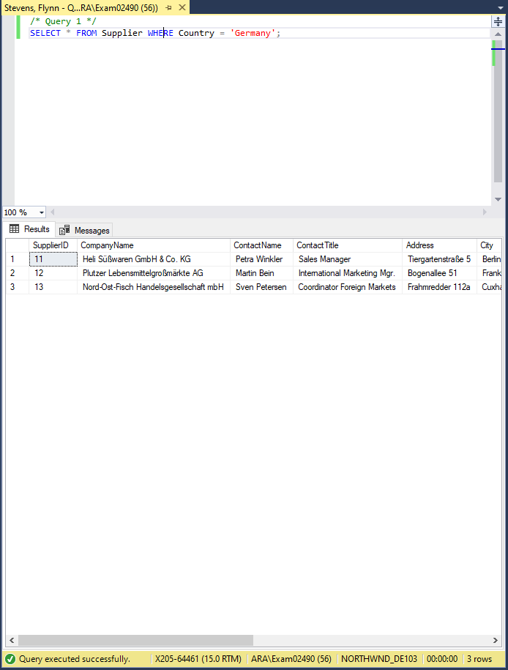

Q2

Q3

Q4

Q5

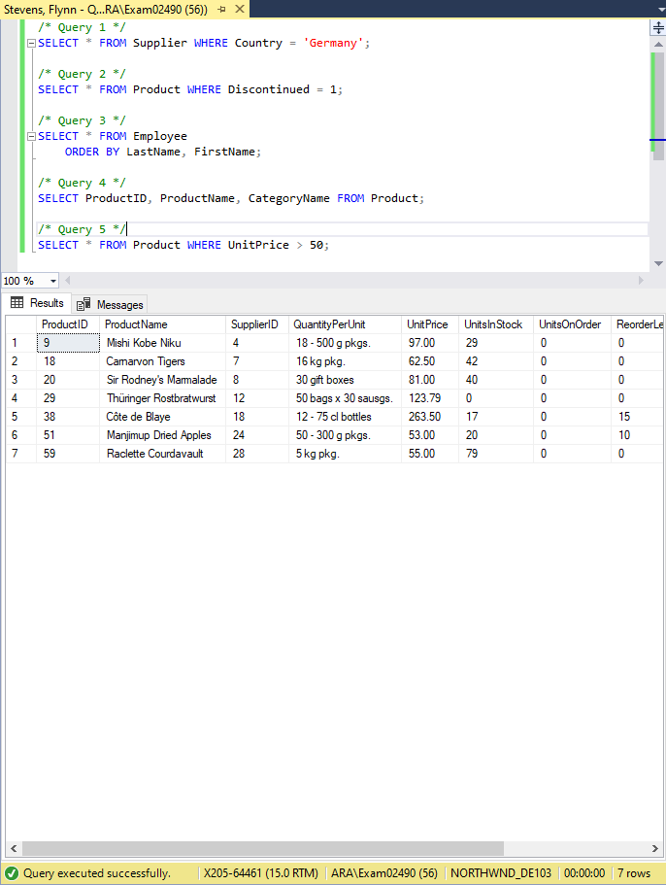

Q6

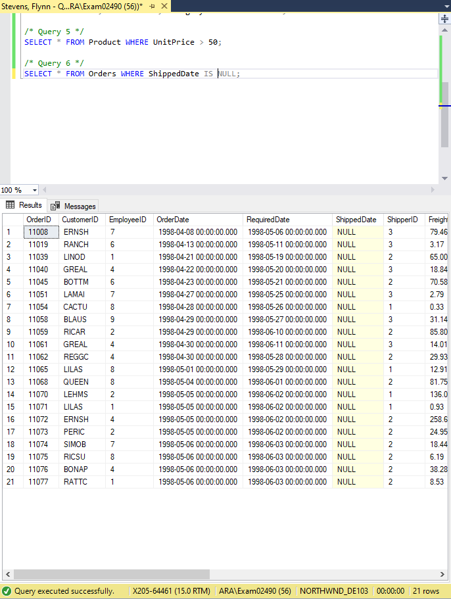

Q7

Q8

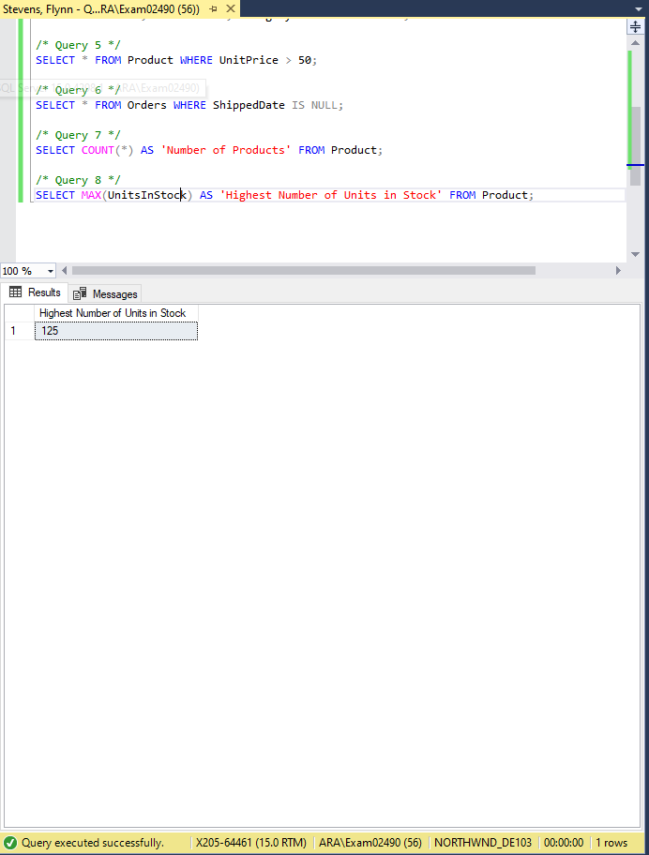

Q9

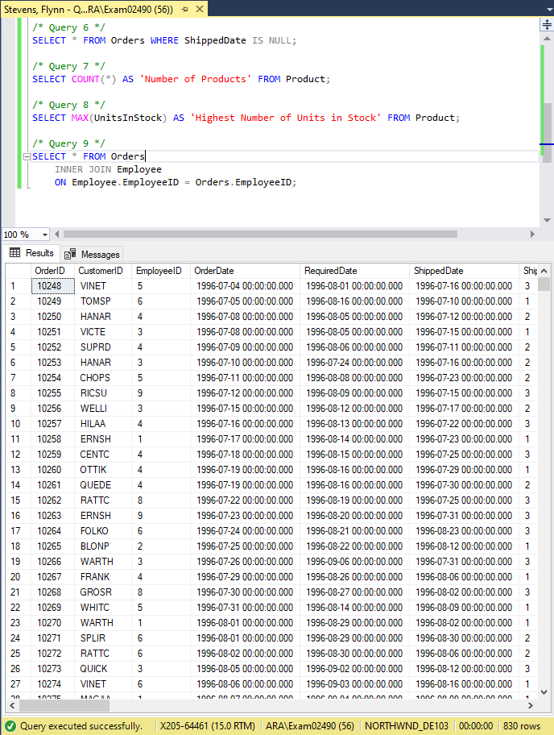

Q10

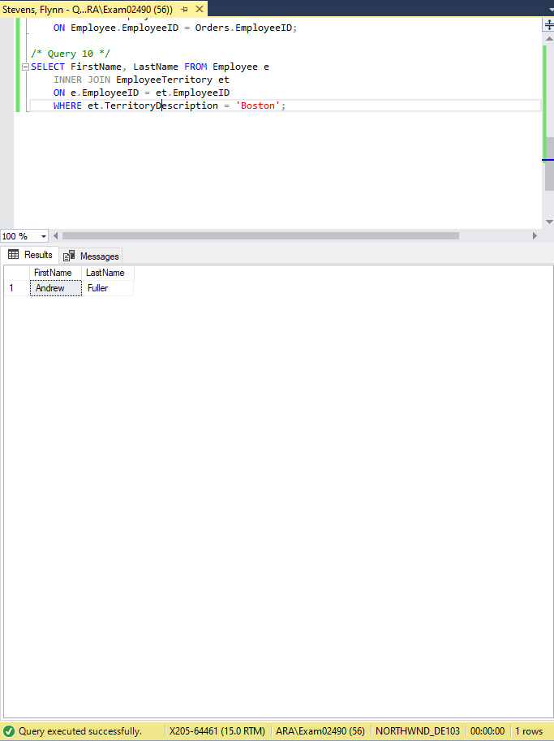

Q11

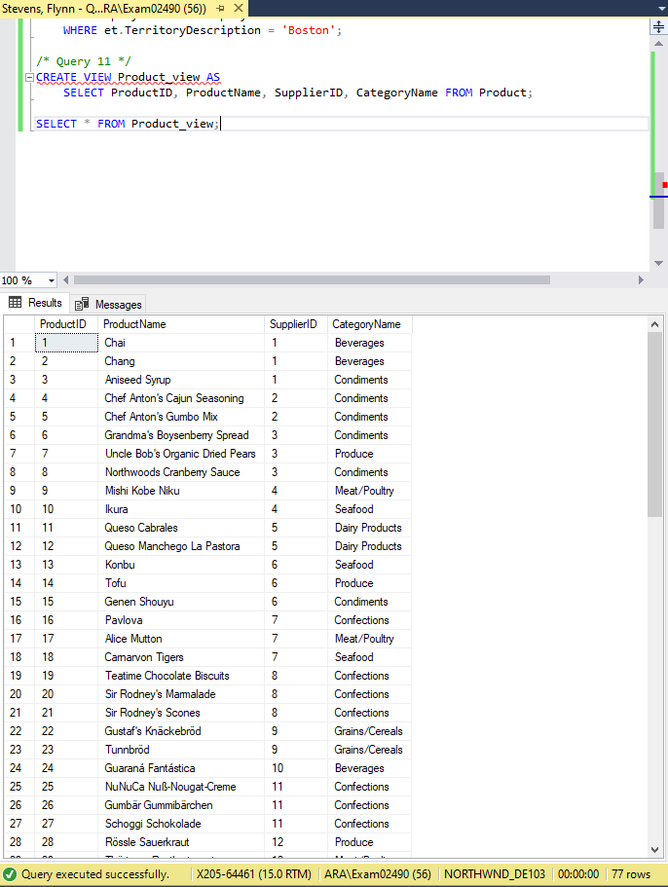

Q12

Q13

Q14

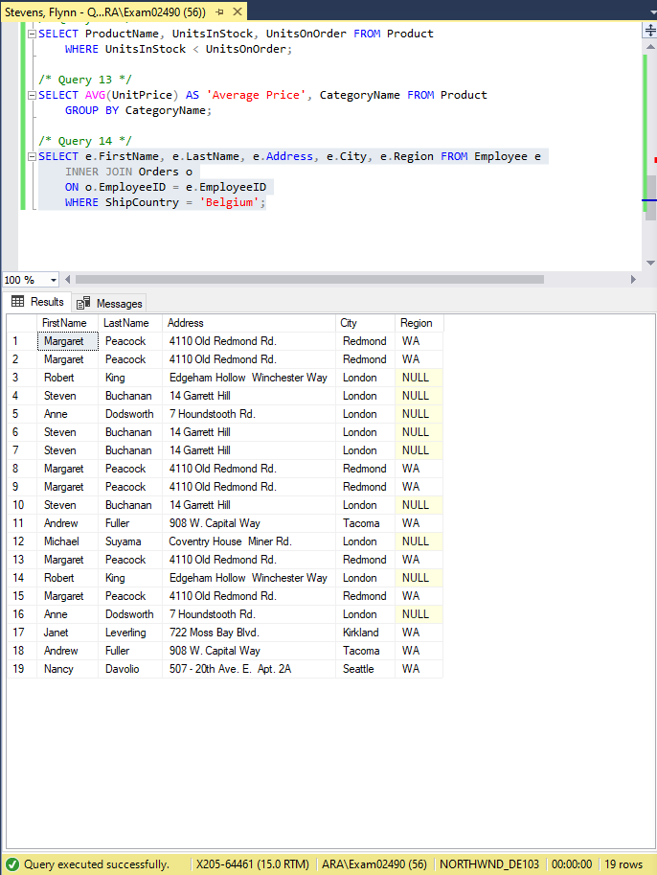

Q15

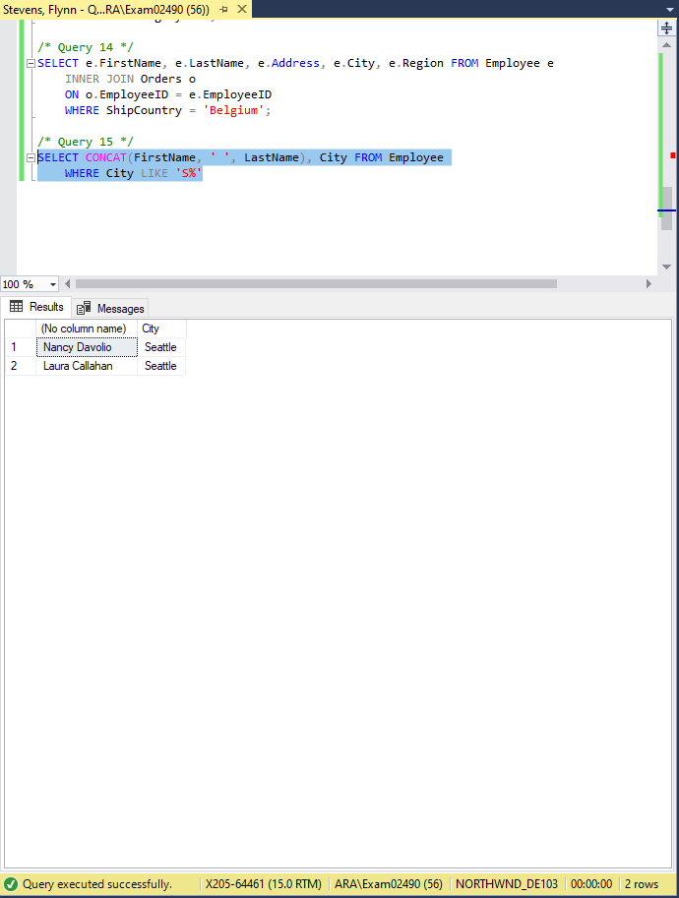

Q16

Q17

Q18

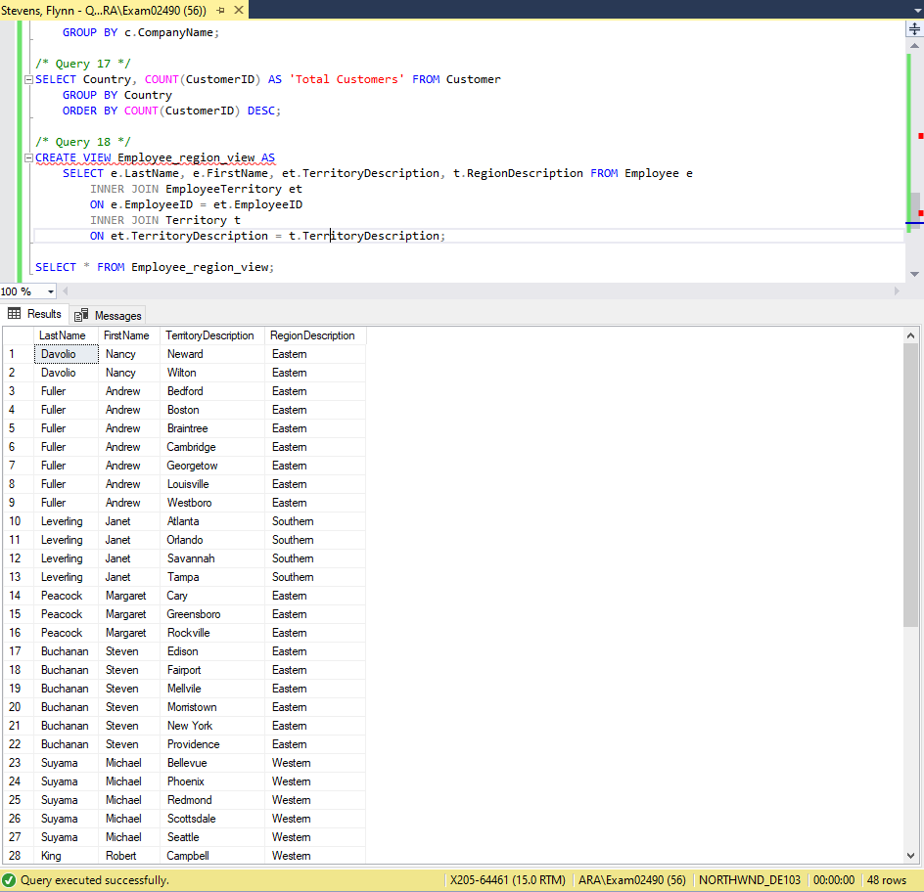

Q19

